# Implementing a Neural Network in Unity

## Project Structure

The Game manager is the heart of the project. It handles the creation of the bots alongside their neural networks, as well as handling other miscellaneous functions. Within the inspector you can set the bots count and their total lifespan in seconds, as well as edit the neural networks structure with additional layers and mutation settings. The game speed can also be edited here for faster learning runs.

## User Input

The bots contain a script, which is deactivated by default, which is used to parse keyboard input for the character movement using WASD.

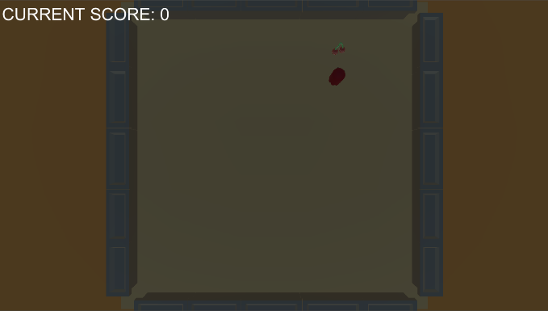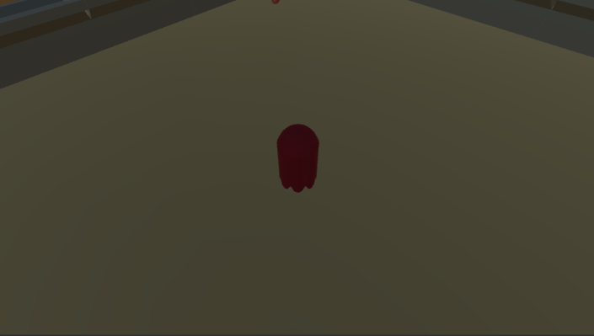The camera can be switched between a third person and a top down perspective with the use of the Q and E keys.

Pressing L will save the latest weights of the neural network, so that they can be loaded at a later date for use.

## Neural Network Functions